

**Runbook - Selenium testing Amazon**

Contents

1.0 About this Guide 2

2.0 Pre-requisite 2

3.0 Required Files/Folders 2

4.0 Data table configuration 3

5.0 Property file 3

6.0 Test case creation 3

7.0 Page object model 3

8.0 Test case execution 4

9.0 Execution report 5

# About this Guide

This document illustrates the utilizing the selenium automation framework which has been integrated with TestNG.

# Pre-requisite

* Need to install have eclipse with TestNG and Maven installed.
* Imported as Maven project.
* Maven POM.xml should have required dependencies like TestNG, Selenium, extent report and apache POI.

# Required Files/Folders

Folder and files should be available as shown below.

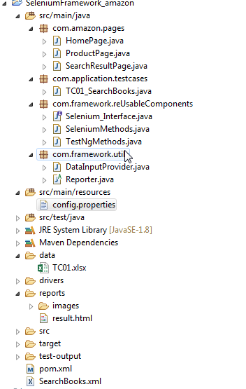

# Data table configuration

Data table should be filled as shown below.

* We need to provide the below items.
  + Category - Which category we need to select from dropdown
  + Product – which product need to be searched.

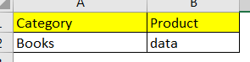

# Property file

We need to provide the below detail in properties file as shown below.

* URL- Application URL.
* Platform – windows/mac.
* Browser – chrome/firefox

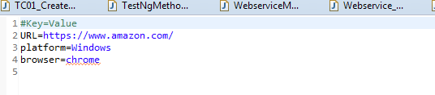

# Test case creation

Test cases should be created in the path **src/com.application.testcases. Also, the class should extend the reusable class.**

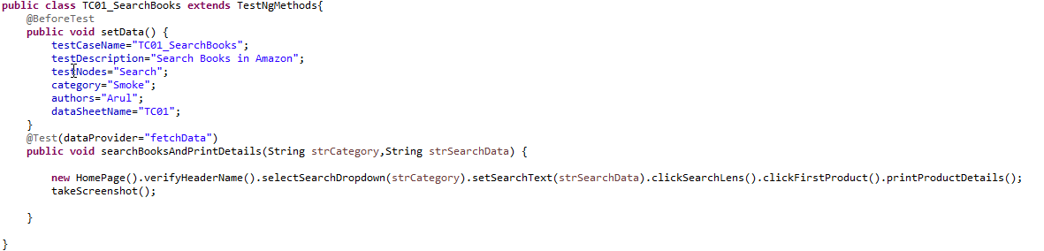

# Page object model

* We have **com.amazon.pages** package**, where we have written page object model classes for the application.**
* **Here we are using Pagefactory to find the elements with mentioned locator.**

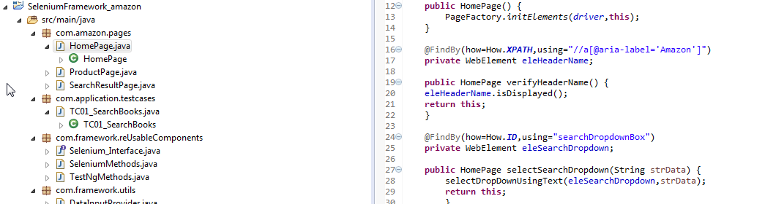

**com.framework.utils** will have the reusable methods which can be used for data fetching and reporting.

# Test case execution

* We need to create a testing suite as xml file by below steps.
  + Right clicking on the project and select convert as TestNG

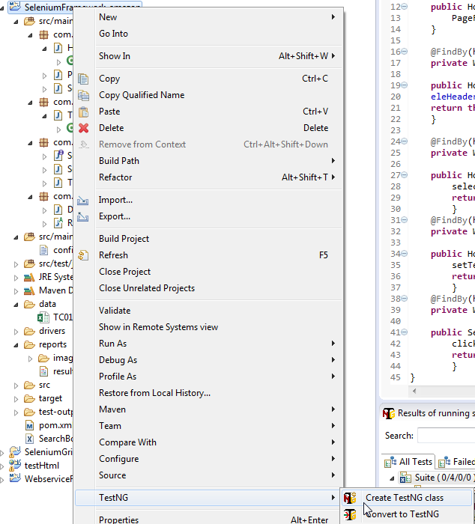

* Once the xml is created, right click on the xml and select Run as TestNG suite.

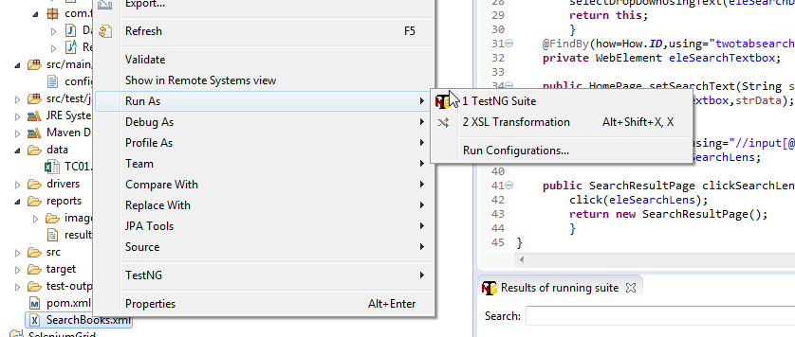

# Execution report

We have utilized extent report and implemented the reporting part to produce html.

Repots will be generated in separated folder called reports. Screenshots will be taken for each steps.

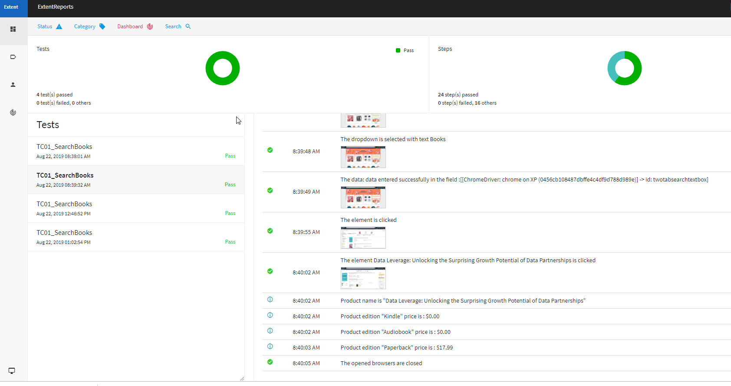

Contact: [Prakash.arul87@gmail.com](mailto:Prakash.arul87@gmail.com)